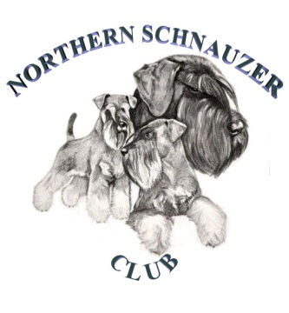
Northern Schnauzer Club Championship Show Saturday 13^{h} November 2021
Elsecar Heritage Centre, Wath Road, Elsecar, Barnsley, S74 8HJ

- ONE FORM TO BE COMPLETED FOR EVERY VEHICLE ENTERING THE SHOWGROUND
- EVERY PERSON IN THE VEHICLE MUST BE LISTED
- TO AVOID DELAY PRE-COMPLETE YOUR FORM, READY TO HAND IN TO YOUR CAR PARK MARSHALL
- ANYONE NOT NAMED ON THE FORM WILL NOT BE PERMITTED TO ENTER THE SHOW
- PLEASE NOTE: EXHIBITORS & VISITORS- NO ENTRY TO THE VENUE BEFORE 9.00AM

NAME | CONTACT NUMBER | EMAIL

As requested by NHS Track and Trace these forms are kept for 21 days following the event, and then destroyed

FACE MASKS MUST BE WORN – SOCIAL DISTANCING MAINTAINED

