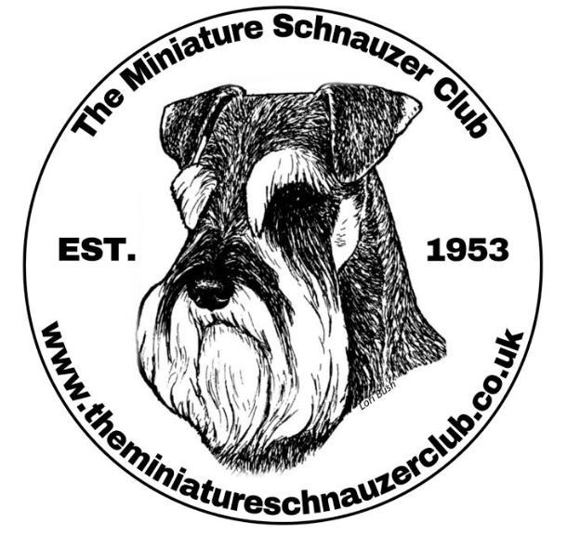
The Miniature Schnauzer Club Championship Show Sunday 7th November 2021
The Kennel Club Building, Stoneleigh Park, Nr Coventry CV8 2LZ

- ONE FORM TO BE COMPLETED FOR EVERY VEHICLE ENTERING THE SHOWGROUND
- EVERY PERSON IN THE VEHICLE MUST BE LISTED
- TO AVOID DELAY PRE-COMPLETE YOUR FORM, READY TO HAND IN TO YOUR CAR PARK MARSHALL
- ANYONE NOT NAMED ON THE FORM WILL NOT BE PERMITTED TO ENTER THE SHOW
- PLEASE NOTE: EXHIBITORS & VISITORS- NO ENTRY TO THE VENUE BEFORE 9.30AM
CAR REG:
NAME | CONTACT NUMBER | EMAIL

As requested by NHS Track and Trace these forms are kept for 21 days following the event, and then destroyed

FACE MASKS MUST BE WORN – SOCIAL DISTANCING MAINTAINED

