Secretary & Treasurer
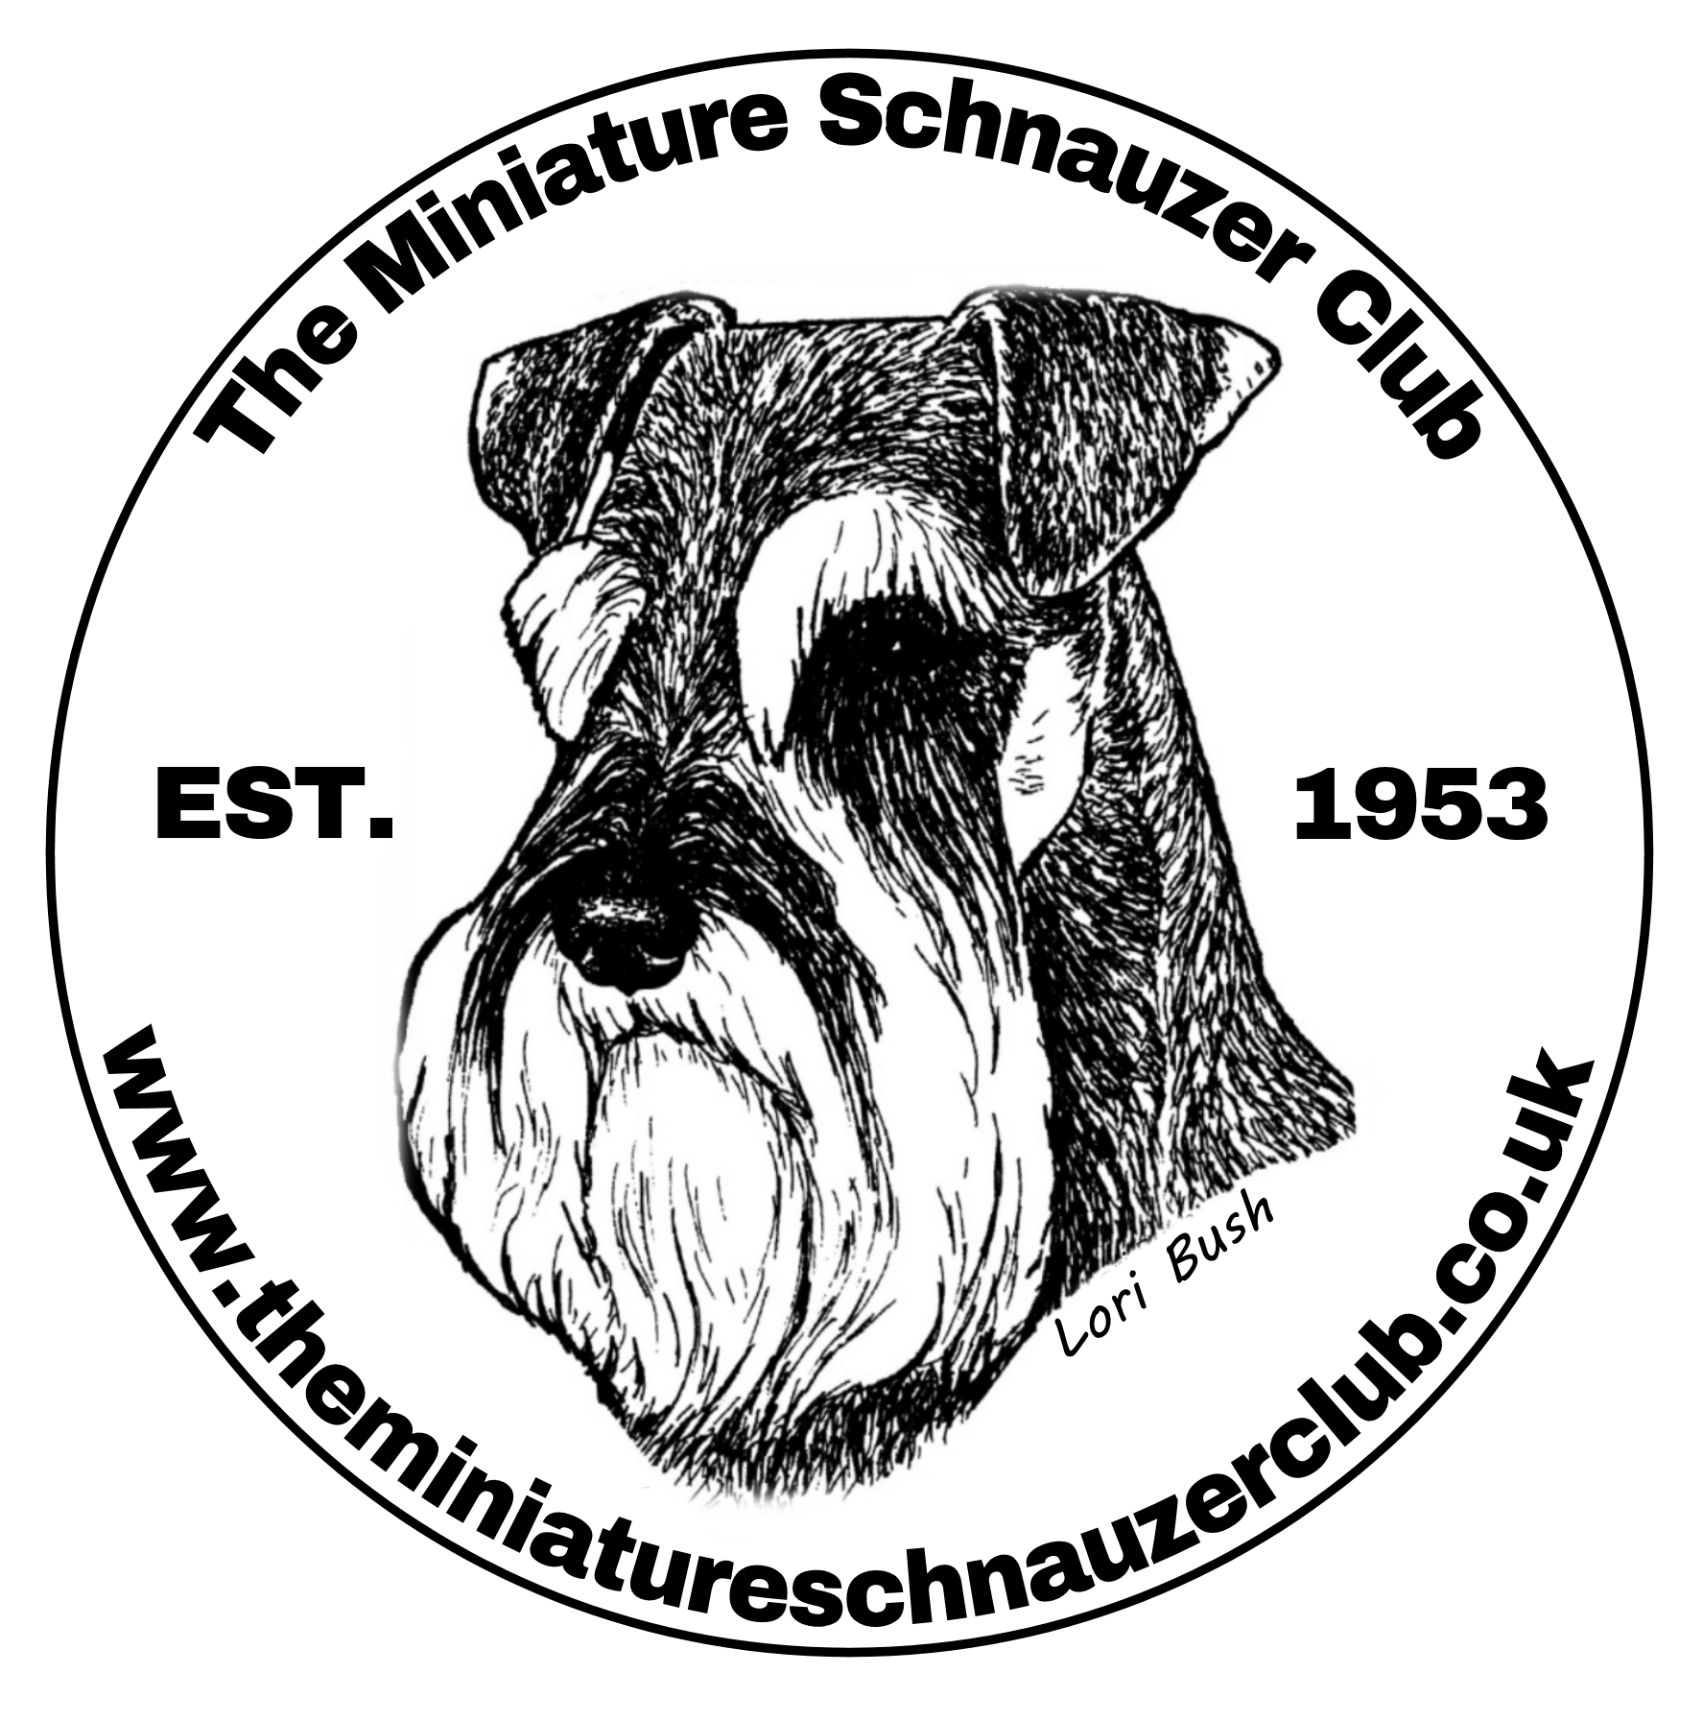
Mrs A P Kidd
Mount Villa
Norton Bridge
Stone, Staffs ST15 0NT
email: miniatureschnauzerclub@gmail.com
- I/We wish to renew my/our Annual Subscription ☐
- I/We wish to become a member(s) of The Miniature Schnauzer Club ☐

The Officers and Committee of The Miniature Schnauzer Club reserve the right to accept or reject any proposal for membership.

NAME
BLOCK LETTERS PLEASE
ADDRESS Click or tap here to enter text.
Click or tap here to enter text.
Click or tap here to enter text.

POSTCODE Click or tap here to enter text.
TEL: Click or tap here to enter text.
Please complete your email address for communication purposes only:
Click or tap here to enter text.

I AGREE TO ABIDE BY THE MINIATURE SCHNAUZER CLUB CODE OF ETHICS.

SIGNED ……………………………………………….. ABS Member Yes ☐ No. ☐

MEMBERSHIP FEE 2023 SINGLE £7.50 ☐ JOINT £9.00 ☐
Cheque/Postal Order/Cash (Cheques payable to “The Miniature Schnauzer Club”
Please Tick if Payment via Bank Transfer ☐
Bank details: acc no: 14709783 sort code: 01 08 32 (please quote your post code as ref)

New Members PROPOSED BY …………………………………………………
(Must Be completed) DATE: Click or tap to enter a date.
DONATION TO REHOME & RESCUE:

Memberships are from January 1st to 31st December and renewable annually.
MEMBERSHIP RENEWAL DATE – 1ST JANUARY EACH YEAR
If you require confirmation of acceptance please include an SAE

Please note by providing us with your information implies that you consent for your details to be kept electronically and or hard copy for contact by the club only. Your information will not be passed on to third parties
For further details of Data Protection you can visit our website. www.theminiatureschnauzerclub.co.uk

GENERAL CODE OF ETHICS
All members of the Miniature Schnauzer Club undertake to abide by its general Code of Ethics.

Club members:
- Will properly house, feed, water and exercise all dogs under their care and arrange for appropriate veterinary attention if and when required.

- Will agree without reservation that any veterinary surgeon performing an operation on any of their dogs which alters the natural conformation of the animal, or who carries out a caesarean section on a bitch, may report such operation to the Kennel Club.

- Will agree that no healthy puppy will be culled. Puppies which may not conform to the Breed Standard should be placed in suitable homes.

- Will abide by all aspects of the Animal Welfare Act.

- Will not create demand for, nor supply, puppies that have been docked illegally.

- Will agree not to breed from a dog or bitch which could be in any way harmful to the dog or to the breed.

- ideally bitches will not be bred from before 18 months of age and not on consecutive seasons i.e. ideally 12 months apart.

- Will not allow any of their dogs to roam at large or to cause a nuisance to neighbours or those carrying out official duties.

- Will ensure that their dogs wear properly tagged collars and will be kept leashed or under effective control when away from home.

- Will clean up after their dogs in public places or anywhere their dogs are being exhibited.

- Will only sell dogs where there is a reasonable expectation of a happy and healthy life and will help with the re-homing of a dog if the initial circumstances change.

- Will supply written details of all dietary requirements and give guidance concerning responsible ownership when placing dogs in a new home.

- ) Will ensure that all relevant Kennel Club documents are provided to the new owner when selling or transferring a dog, and will agree, in writing, to forward any relevant documents at the earliest opportunity, if not immediately available.

- Will not sell any dog to commercial dog wholesalers, retail pet dealers or directly or indirectly allow dogs to be given as a prize or donation in a competition of any kind. Will not sell by sale or auction Kennel Club registration certificates as stand alone items (not accompanying a dog).

- Will not knowingly misrepresent the characteristics of the breed nor falsely advertise dogs nor mislead any person regarding the health or quality of a dog.

- Members will submit breeding stock to the KC/BVA Eye Scheme for screening and will make available copies of the relevant documents to purchasers of their stock.

“All members will submit puppies & breeding stock to comply with the KC/BVA eye scheme and will make available copies of the relevant documents to purchasers”.

Breach of these provisions may result in expulsion from club membership, and/or disciplinary action by the Kennel Club and/or reporting to the relevant authorities for legal action, as appropriate.

